GROUP MEMBERS:
P19-1673---Wahaj Tahir

P19-1672----Ahmed Sattar

P19-1652---- Hifza Majeed

Subject:
Software Requirement Engineering

Project Name:
Bus reservation system

Online Bus Ticket Reservation System

Abstract:
Online Bus Ticket Reservation System is a Web based application that works within a centralized network. This project presents a review on the software program “Online Bus Ticket Reservation System” as should be used in a bus transportation system, a facility which is used to reserve seats, cancellation of reservation and different types of route inquiries used on securing quick reservations.

Background of Study:
The prevalent view in various global circles is that man is presently living in an age growth of information gathering, processing and dissemination, popularly called the information age. For this reason, managers and other users of information especially in transport industries are demanding more kinds of information to support management and operations. They must therefore respond to the increasing requirement for information and data management.
Electronic tickets, or e-tickets, gives evidence that their holders have the permission to enter a place of entertainment, use a means of transportation, or have access to some Internet services. The design of this online system will be beneficial to the company because it has not existed before.
Therefore, Transport Company, Owerri, a viable investment owned by the state government whose primary objectives are: to spread comfort and hospitality to passengers away from their home, to make profit, will definitely appreciate a system which can automate its manual operations in the area of bus ticket reservation in order to meet customers increasing demand during peak and off peak seasons. The ultimate expectation is to inspire a feasibility study aimed at providing proper guidance and awareness to any future potential investors, particularly those in the bus industry, to consider utilizing the transport, as a gateway to the fertile soil of unlimited opportunities in the south-east Nigeria.
Currently, staff at the bus ticket counter is using an internal system to sell tickets at the counter and customers who are unable to buy bus ticket online at this moment would have to go to the counter to a buy bus ticket. Sometimes, customers’ needs to queue up a long queue to buy bus ticket and ask for information and this brings a lot of inconveniences to customers.
However, Online Bus Ticket Reservation System enables the customer to buy bus ticket, make payment, and ask for information online easily. Furthermore, staff can sell bus ticket using Bus Ticket Reservation System after checking the bus ticket availability for the customer and print the bus ticket to the customer.

Business Opportunities:

- Online Bus reservation system increase the Revenue. As it will be a new thing to people and they will give a try.
- If revenue increase than it will give opportunity to expand the business by adding more buses like Double Decker Bus.
- If you add more buses than you will be able to hire more qualified and good staff.
- People will Sponsor your company which will add value to you reputation.
- By doing this your business can be expand to all around the Pakistan.

Business Objectives:
The main purpose of this study is to automate the manual procedures of reserving a bus ticket for any journey made through Transport Company (TC). This system is said to be an automatic system and customers can select seats by themselves. Specifically, objectives of this project will consist of:
i) Providing a web-based bus ticket reservation function where a customer can buy bus ticket through the online system without a need to queue up at the counter to purchase a bus ticket.
ii) Enabling customers to check the availability and types of buses online. Customer can check the time departure for every TC bus through the system.
iii) Easing bus ticket payment by obtaining a bank pin after payments is made to the various designated banks.
iv) Ability of customers to cancel their reservation.
v) Admin user privileges in updating and canceling payment, route and vehicle records.

SUCCESS METRICS:

- Previously:The record of the customer were use to save in hard form like paper which was not efficient when need arises.
- Now:The record of customer is save in database with proper maintenance easy to access which saves our time and bring efficiency.
- Previously:It was hard to track the customer data in history because of lot of data were on hard form.
- Now:By typing user contact number in system you will get the whole customer data which was you searching for.
- Previously:The revenue generated in a month was 30%
- Now:The revenue will generated more than 50%.
- Previously:Rate of using this transport was 20%.
- Now:Rate of using this transport is now 40%.

VISION Statement:

Our vision is Magnificent Marketing new web application system will increase revenue though increased customer satisfaction. Customer projects will be completed on schedule because equipment will be reserved in conjunction with schedules. The new application will be accompanied by an enhanced database management system as well as a secure employee portal. This will increase the data security and user privacy.

Business Risk:

With the introduction of the new system, more security measures have to be placed on the network, because without adding more security features in the network the risks increase. Not only will a database be introduced, but now the database has employee information and users have to sign in to reserve equipment to insure that only authorized users have access to the database. So it is at risk in case if the user data leaked out or Misuse will lead to failure of good business and no one will goanna trust you again. “Trust” element plays a very important role in business principles.

Assumption and Dependencies:

- Assumption: The current paper reservation form is the basis of design of the new online reservations.
- Dependency: When the online reservation system is in place, the paper form will become a backup option for registration
- Assumption: The nature of the online application requires client/server architecture, network hardware and software, server hardware and software, database software, and development software.
- Dependency: Establishing relations with various software and hardware vendors will fulfill the hardware and software requirements of the project.
- Assumption: The new system will show the inventory in real-time and show future returns, which will allow users to make reservations accordingly
- Dependency: This should increase employee productivity, hence increasing revenue through customer satisfaction.
- Assumption: Additional training of staff is foreseen for staff to handle new protocols, hardware, and software.
- Dependency: Additional training time allowed for staf

Scope and limitation:

- Major features:

The major features involves following
- Having information about name, id, phone no, address, email account.
- Price list
- Information about where you want to go and
- Seating chart that how much seats are remaining
- Payment information
- There will be comments and suggestion section for users.
- It will also be easy for management to maintain record.

- Scope of initial release:

The initial release of the system will include the online reservation system form where the basic information will be saved, database to process and store reservation information and an employee web portal installation, configuration, and support documentation will be included with the initial release. This scope of initial release will provide all the information that will be necessary and basic for reservation.

- Scope of subsequent release:

This scope of subsequent will be given after the growth of our business and that subsequent will be following

- Online viewing of reservation information
- Online viewing of who has what equipment
- Email remainder of upcoming reservation
- Online cancellation capability
- Allow rescheduling of reservation
- Online mapping that when will this bus reached

These are the subsequent that we will be given business growth.

- Limitation and exclusions:

With the initial release employees will not be unable to cancel, reschedule or view reservation information online. To accomplish that, employees must notify the inventory clerk by phone, e-mail, or by walk in. In addition, employees will have to remember their reservation schedules and will not be able to see who has what equipment.

Business context:

Deployment Consideration(summary):

Online Bus Ticket Reservation System being a web based system that ensures that the company would be able to transform most of the processes carried out manually into automated, error-free and easy to use operations in the organization especially in the area of transportation; also it would be able to generate report for the management decision purpose.Staff should know how to interact with system.

Stakeholder Profile:
Internal Stakeholder:
a) Administrator (Head)
b) Operator (Counter Master)
c) System Analyst
d) Database Administrator
External Stakeholder:
a) customer /Visitor
b) bus agencies
- Owner
- Employees
- Payment third party

Context Diagram:
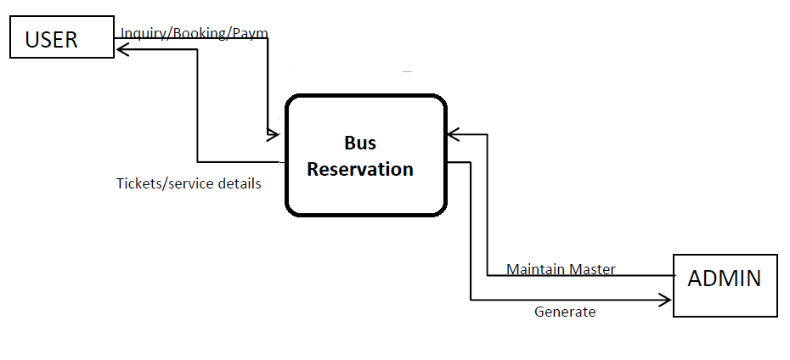

Ecosystem Map:
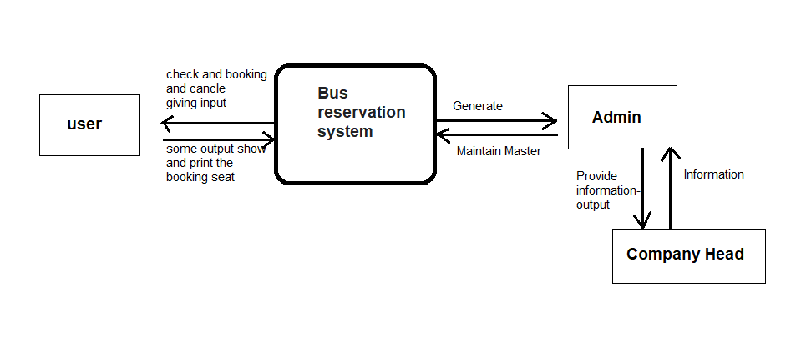

Feature Tree:
